**Research Question 2**

***RQ-2:*** *Do practitioners agree with the identified source code properties?*

Since we did not carry out a survey to collect the opinions from the practitioners, the survey data attached to the paper is used to answer the second research question.

The following table gives us an idea about the experience of interviewees involved in the research. Most of the interviewees have experience in software development between 3 and 5 years, and from the table, we can assert that over half of the practitioners involved are experienced.

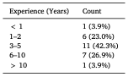

According to the agreement statistics, most practitioners consider “Include” to be the most important feature affecting defectiveness. “Hard_coded_string” is among the three properties having the highest importance and is agreed upon by the practitioners. “URL,” which does not actually have a high importance value in the random forest, also tends to be an essential property, according to the practitioners. The data suggests that practitioners have different opinions on the importance of code properties. However, we question that the difference may be caused by a small response rate of 7.4%, that only a very small portion of the interviewees responded to the survey. The small dataset may not be representative enough for the distribution.

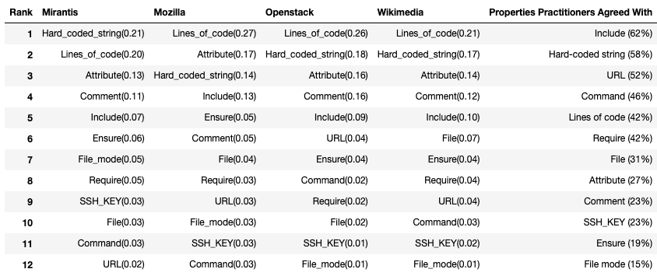

A deeper insight can be gained through observing the following table, with detailed agreement degrees presented. From strongly disagree to strongly agree, there lies five different levels. The importance of “File mode” is very neutral.

